**Experiment 1: Vacuum Cleaner Problem**

**Group 1 Members**

KRAIG OCHIENG OMONDI - P15/2138/2021

EUGENE WAINAINA KINYANJUI - P15/6607/2021

BRAISON ORINA - P15/142382/2021

JOSEPH WANYOIKE WAMAE- P15/37390/2016

WISDOM JOHN MAKOKHA - P15/81777/2017

**Configuration and Execution**

1. The source code was downloaded from [here](https://web.ntnu.edu.tw/~tcchiang/ai/Vacuum%20Cleaner%20World.htm).
2. The file *Agent.exe* was executed.

***NB: The code only runs on Windows.***

**Screenshots**

The screenshots below show the action of the vacuum cleaner after 100 steps each.

The vacuum cleaner is *green* by default, *red* when it bumps into a wall, and *orange* when it sucks dirt.

It is *triangular* when moving and *square* when idle or sucking dirt.

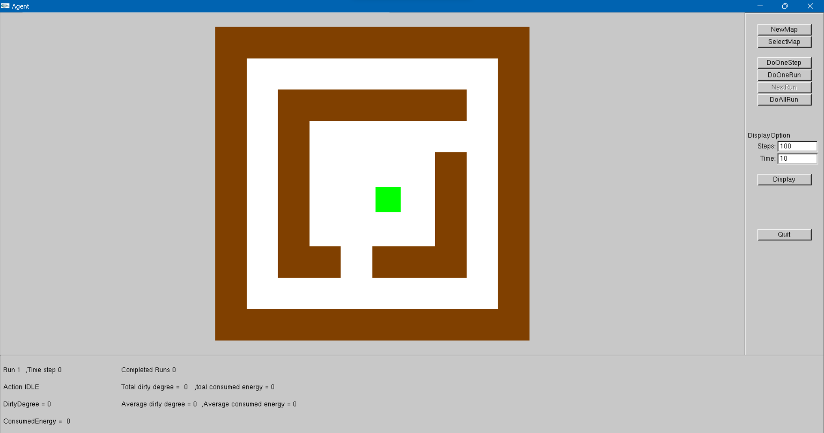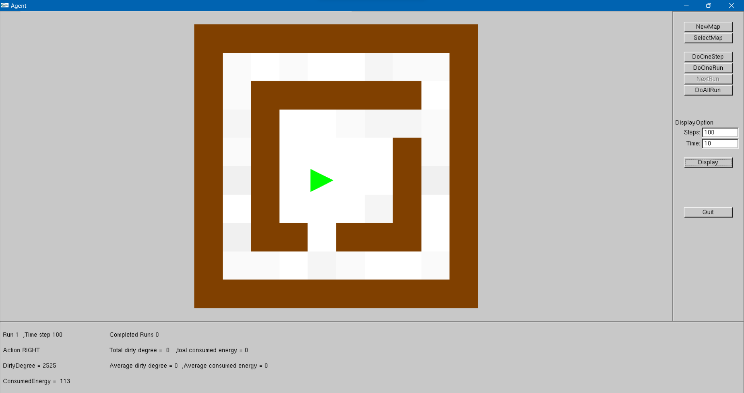

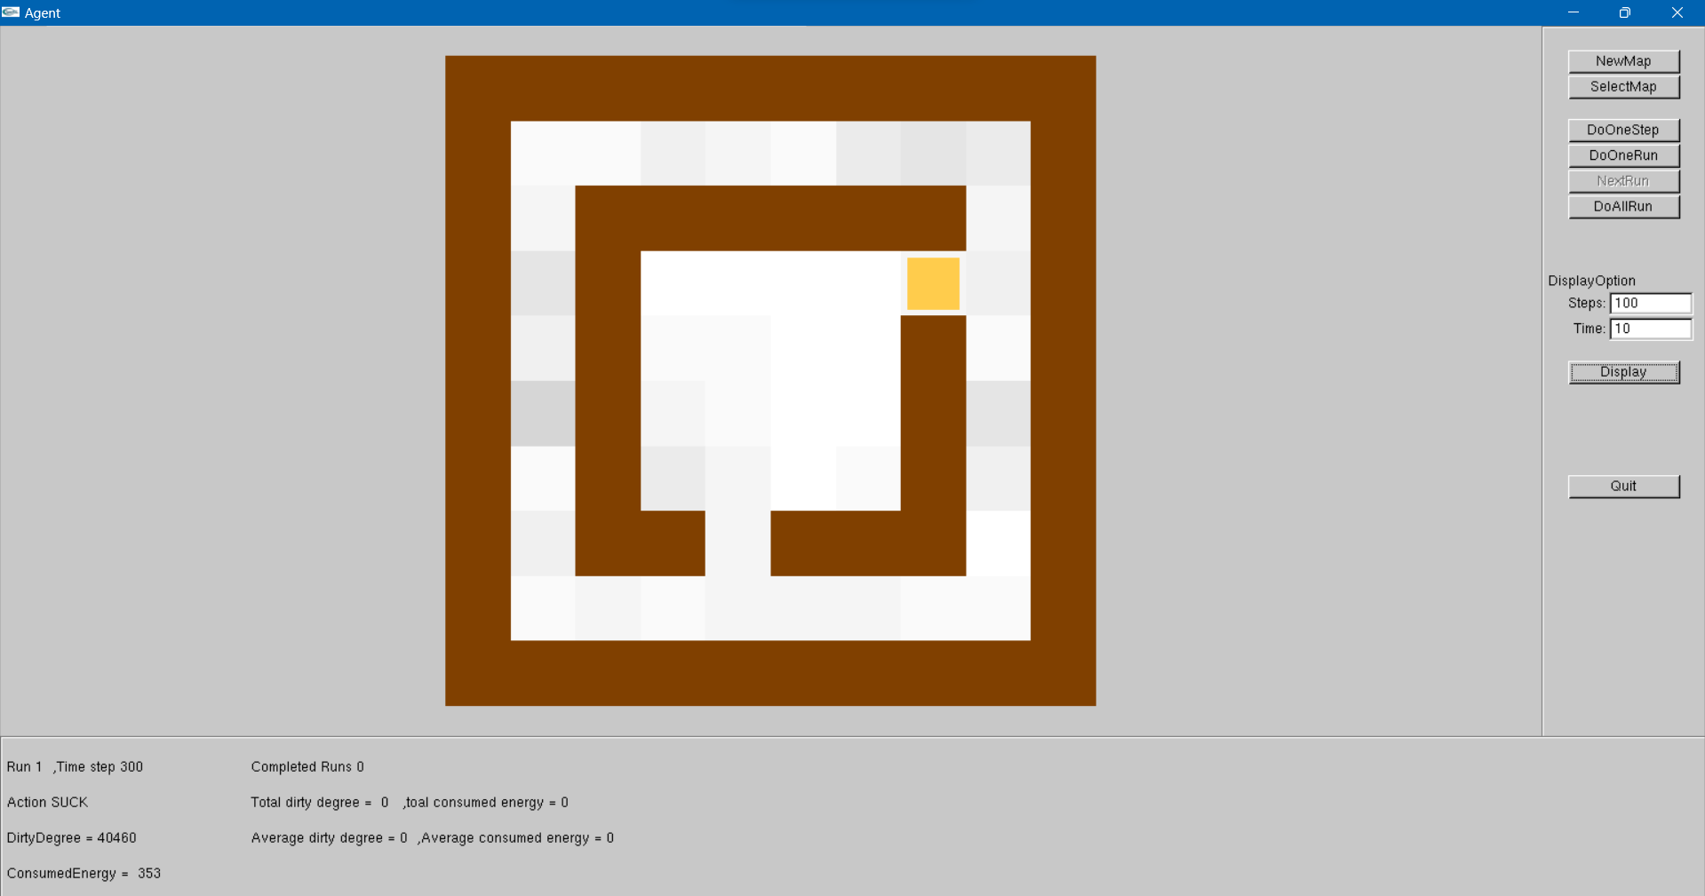

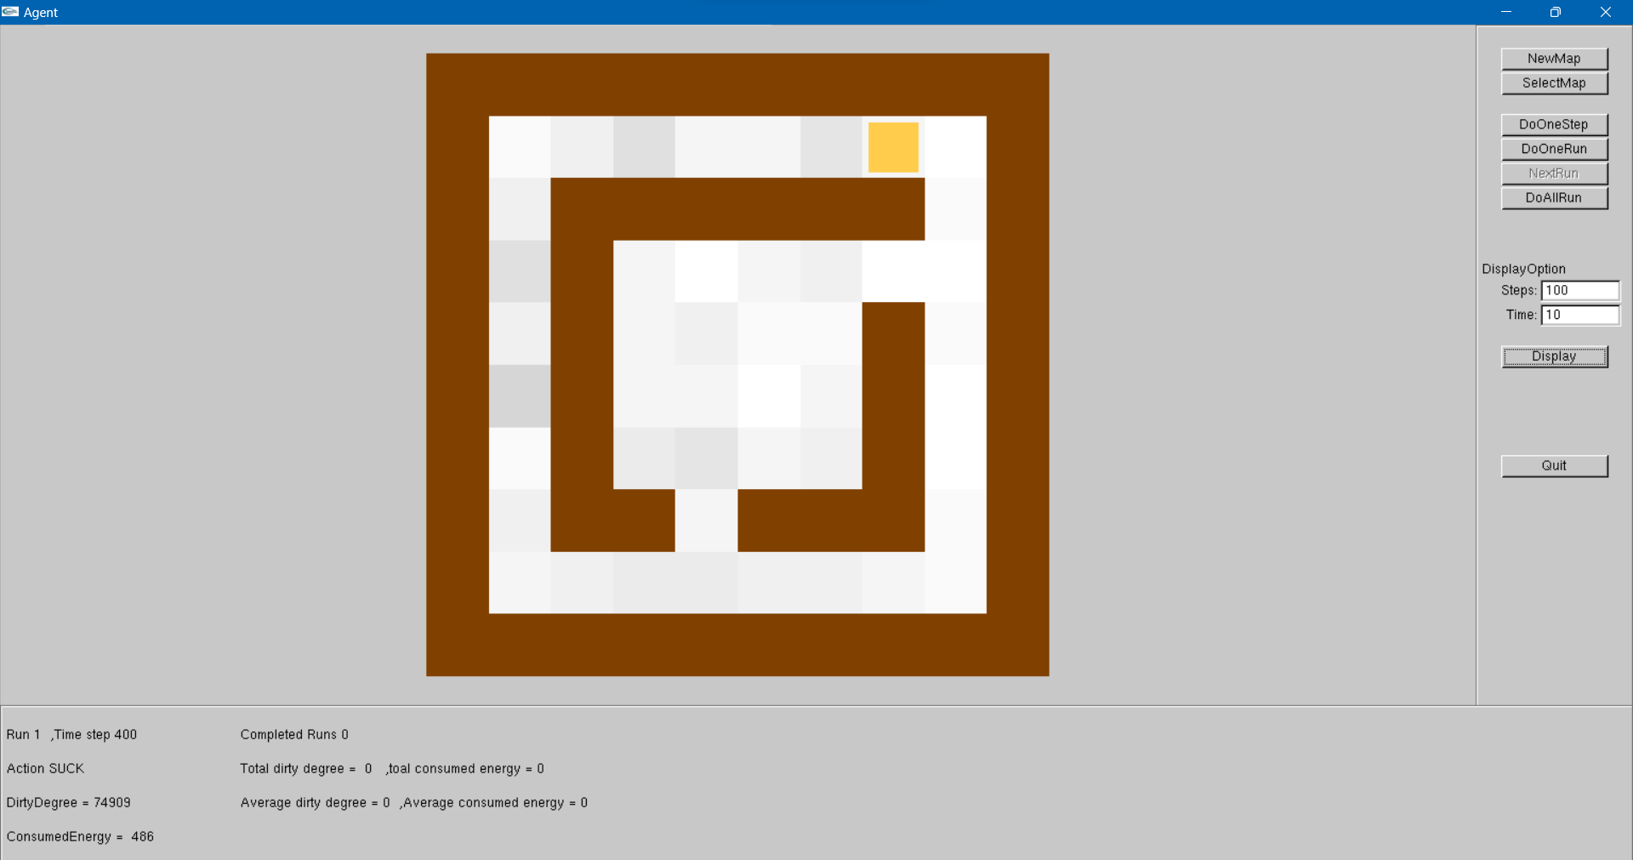

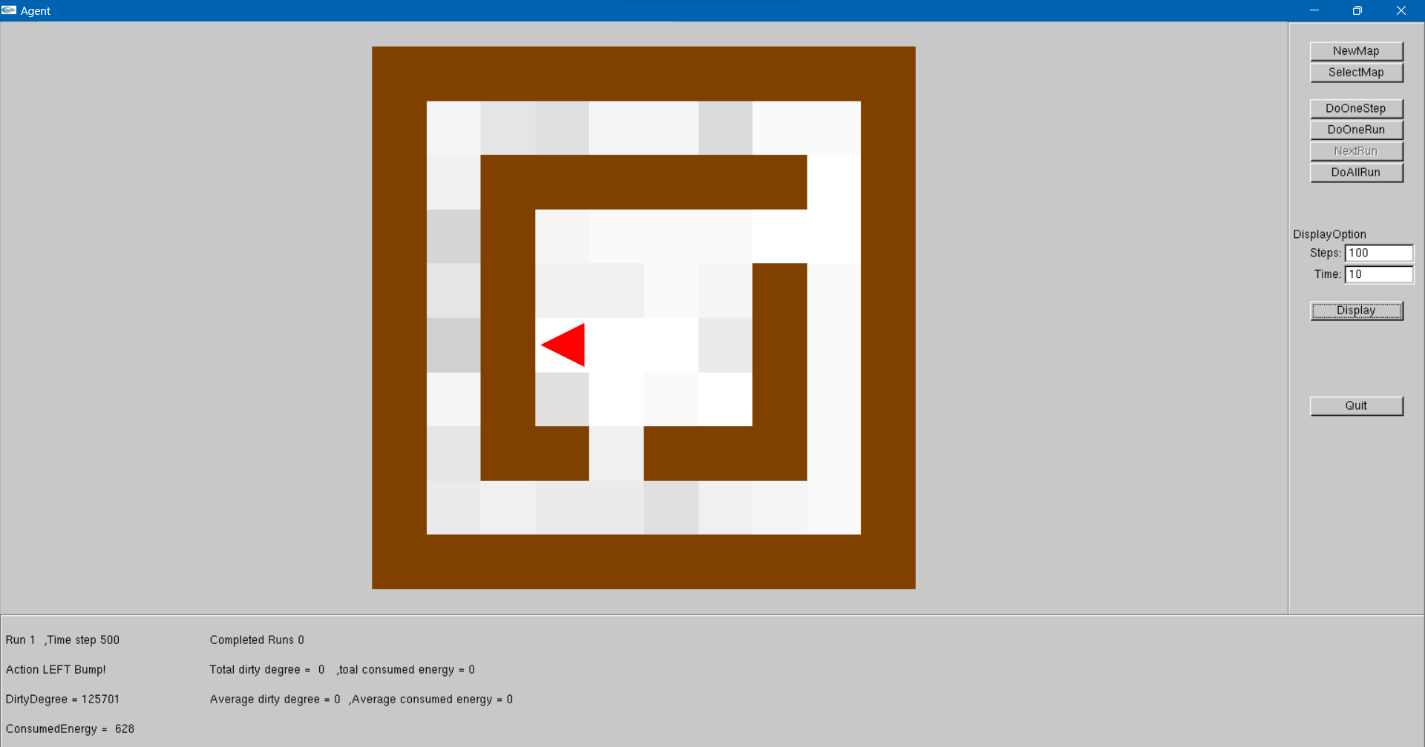

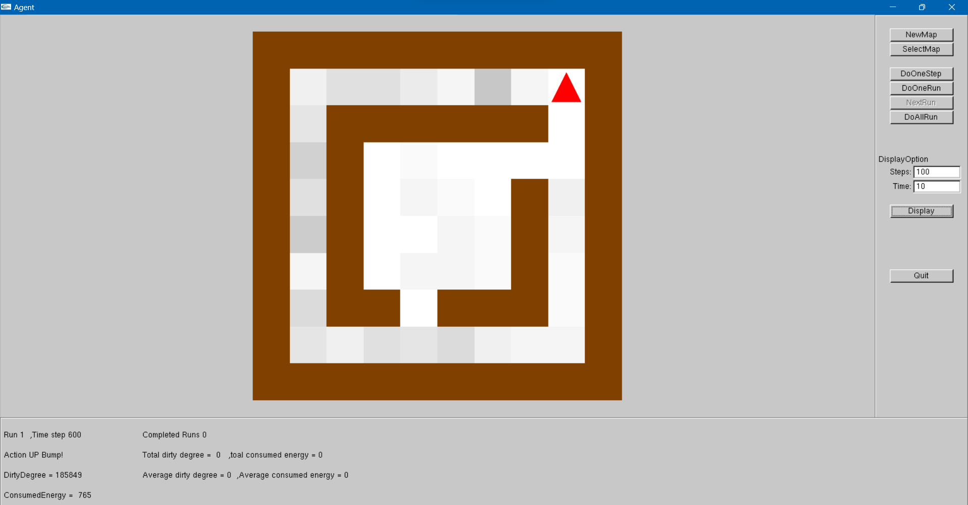

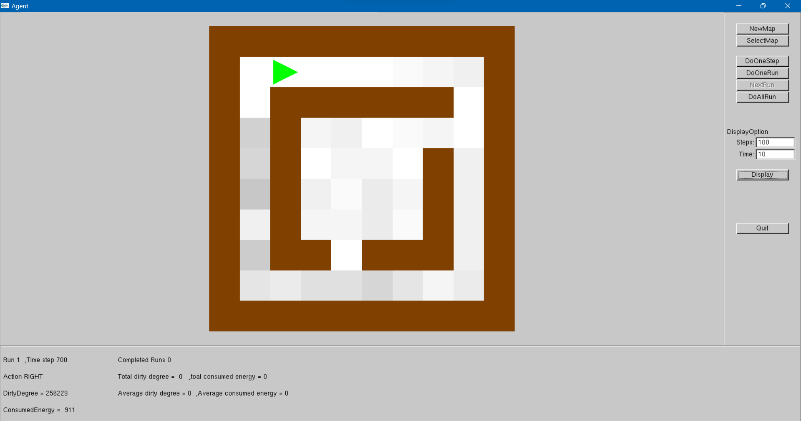

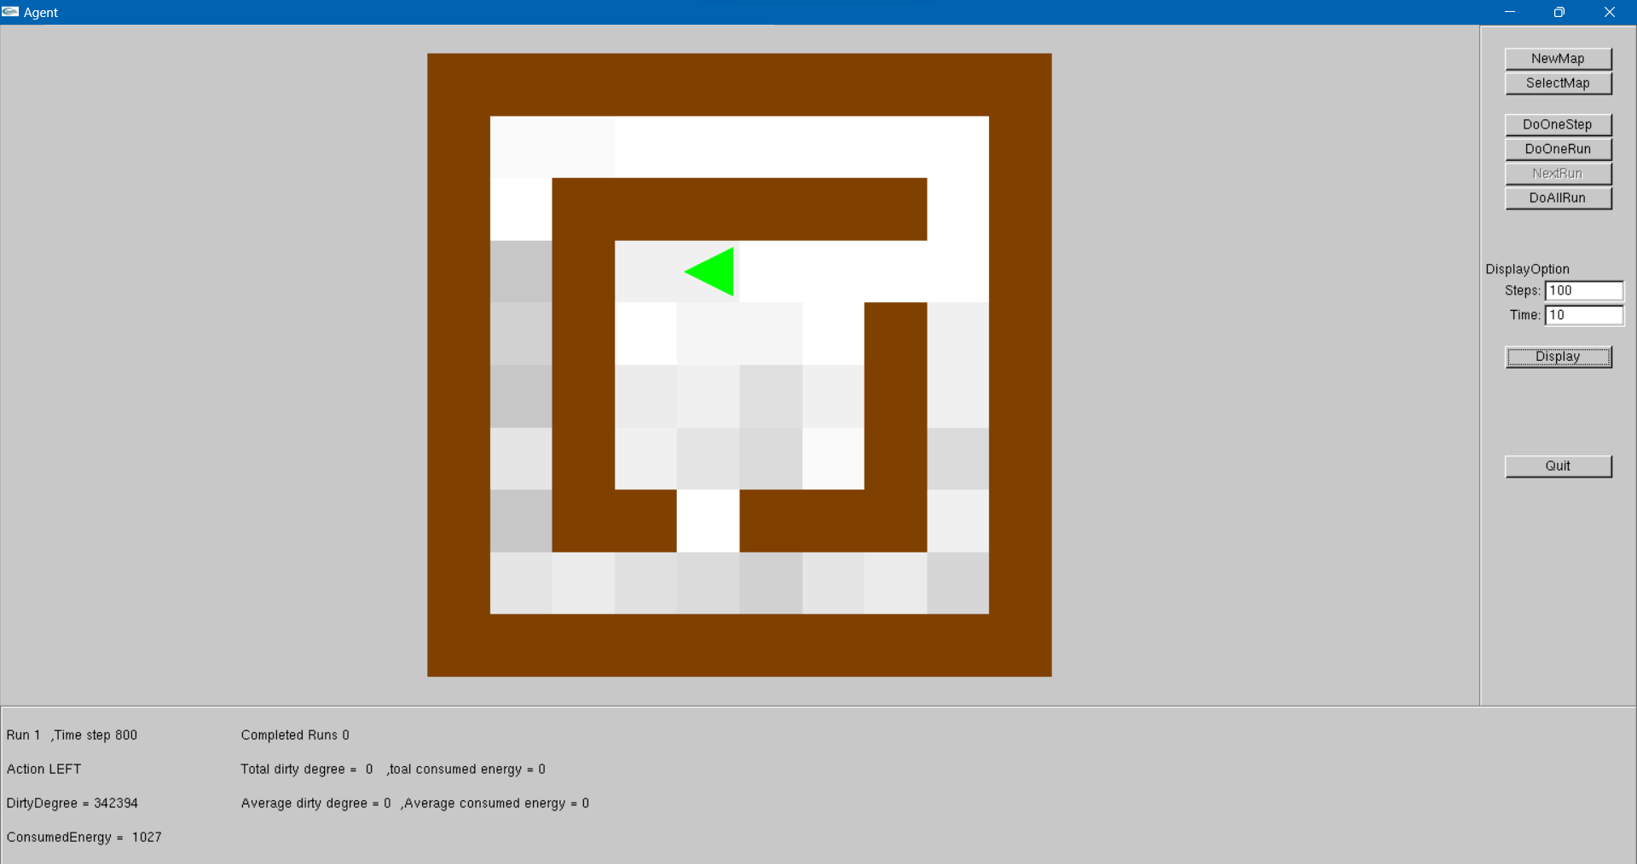

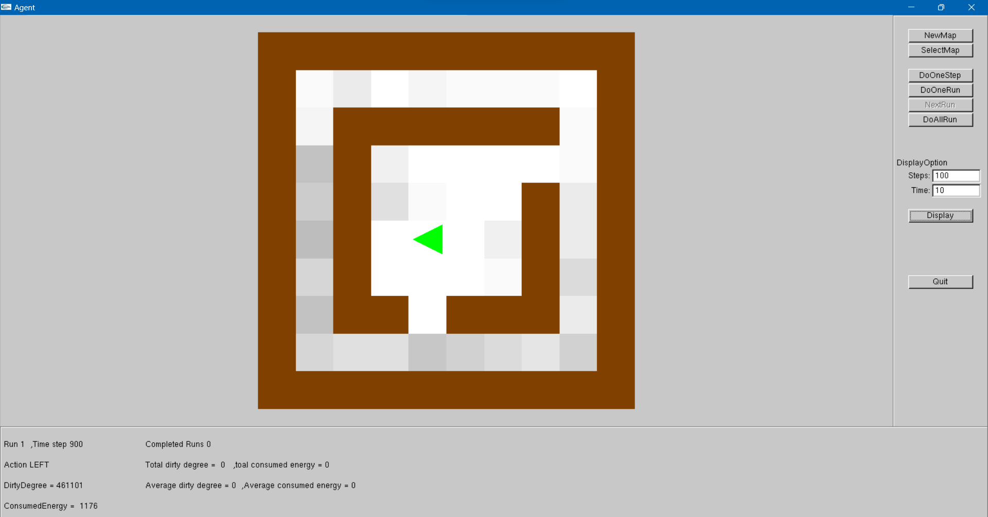

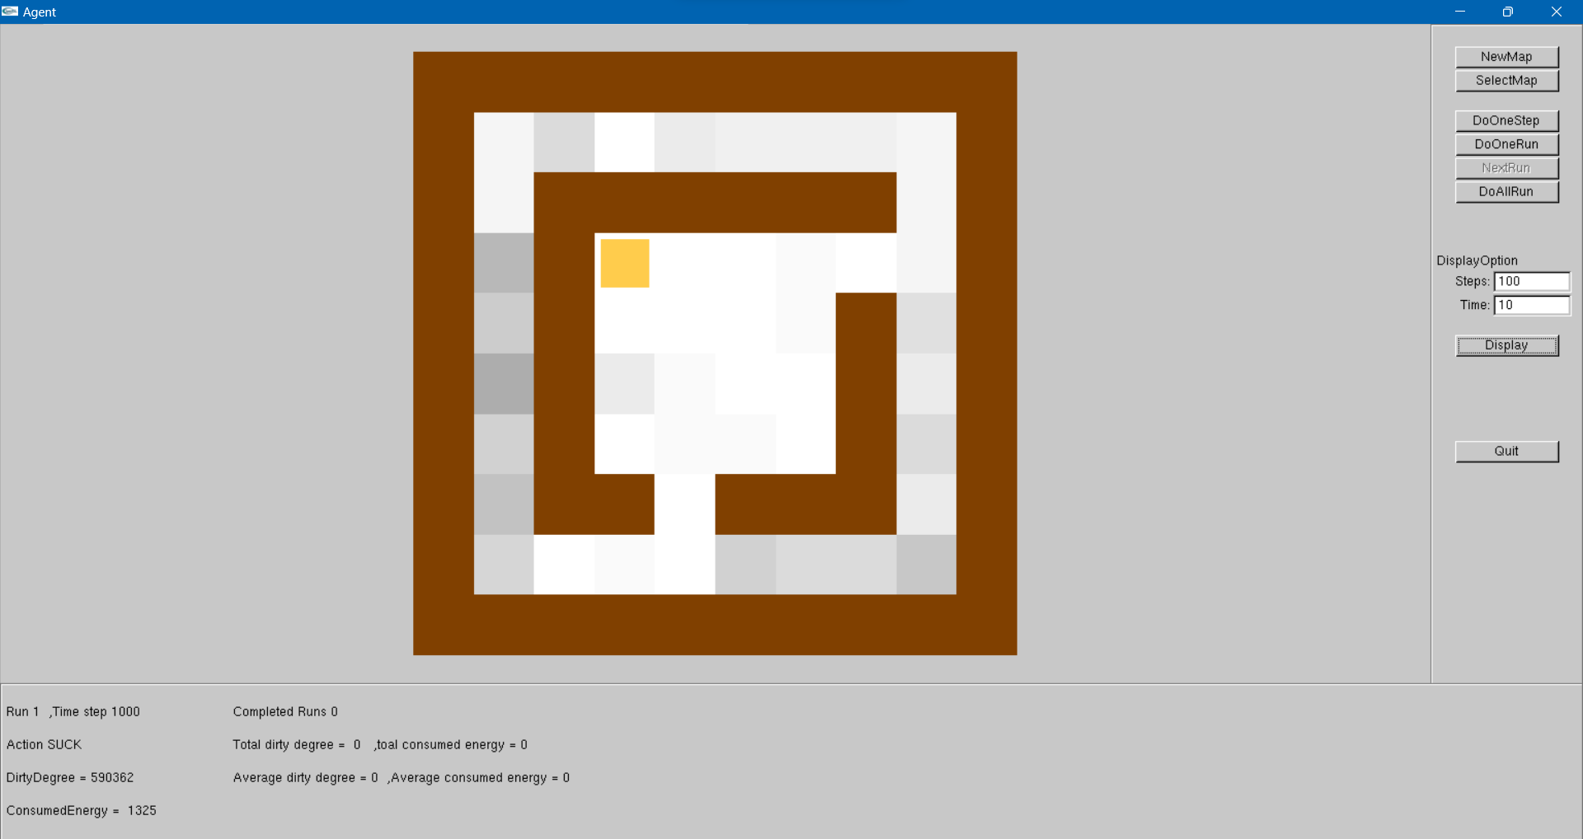

**Description**

The vacuum cleaner’s movement appears random, as it does not seem to be able to sense dirt around it. From the observed behaviour, it would pass by a dirt block and not move in its direction. It would also sometimes bump into the same wall up to 3 times.

**Evidence**

The dirt degree increases with each run exponentially.

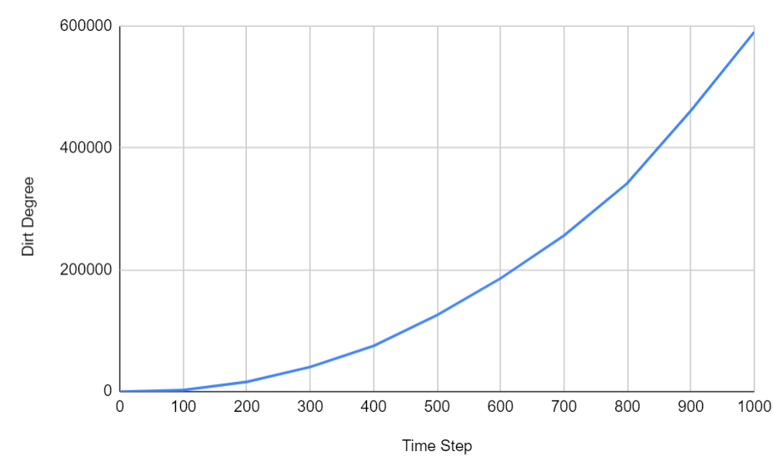

Further more, from the code below, we can actually see that the action of the vacuum cleaner **is** randomly chosen from the ActionType Enum (go up, go down, go left, go right, suck dirt, or idle).

The random selection (File: agent.cpp)

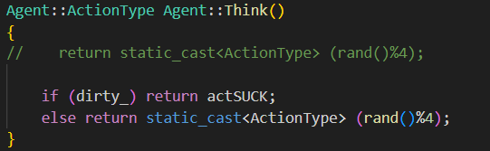

The Enum class ActionType (File: agent.h)

